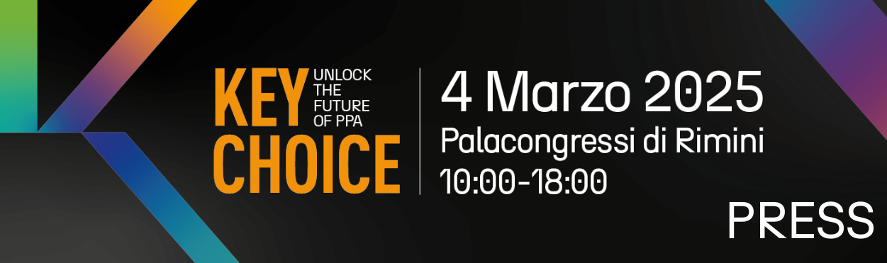

press release

IEG, BACK IN RIMINI, KEY CHOICE – UNLOCK THE FUTURE OF PPAs:
CORPORATE PPAs, A TOOL FOR ENERGY-INTENSIVE COMPANIES
TO CONTROL COSTS, MITIGATE RISKS AND IMPROVE SUSTAINABILITY

- Second edition of KEY - The Energy Transition Expo, the event organised by Italian Exhibition Group in cooperation with Elemens and with the support of SolarPlaza
- Scheduled for Tuesday 4th March at the Palacongressi in Rimini

Rimini, 27th February – Finding the most suitable tools to mitigate, control and contain energy costs while reducing emissions and increasing competitiveness is a corporate priority, especially for energy-intensive companies. In this scenario, Power Purchase Agreements (PPAs) are proving to be a strategic solution by offering protection from price spikes and representing an option for decoupling from volatile gas costs. KEY CHOICE - Unlock the future of PPAs, KEY - The Energy Transition Expo’s B2B event, organised by IEG (Italian Exhibition Group) in collaboration with Elemens and with the support of SolarPlaza, will once again spotlight this so decisive tool for the future of energy.

The second edition of KEY CHOICE is set to take place at Rimini’s Palacongressi Conference Centre on Tuesday 4th March, just prior to the appointment with KEY - The Energy Transition Expo, which will instead take place from Wednesday 5th to Friday 7th March at the Expo Centre.

2025 will be a crucial year for the development of renewable energy thanks to the implementation of Energy Release and the start of the RES X decree’s first auctions.
According to an analysis by consultancy firm Elemens, the Corporate PPA segment in Italy broke a record in 2024 by accounting for around 60% of the total amount of new capacity contracted through PPAs (around 1 GW).

“KEY CHOICE is one of the initiatives that KEY is dedicating to its community,” explains Alessandra Astolfi, Global Exhibition Director of IEG's Green & Technology division. “In fact, KEY is not just an Expo, but also a producer and container of high-quality content, which goes beyond the three days of the Show, intercepting the new needs of the market to offer companies and professionals an integrated vision of all the tools and technologies available to rationalise consumption, improve energy and environmental impact and control energy costs.”

The one-day event, from 10 am to 6 pm, will be organised into two parts. The morning session, from 10 am to 1 pm, will be dedicated to interaction between the parties with business meetings and networking opportunities.

“With KEY CHOICE we address not only energy-intensive companies, but also renewable energy producers, traders, off takers, electricity system institutions and financial institutions,” explains Christian Previati, KEY Exhibition Manager. “Our aim is to put energy suppliers into contact with energy-intensive companies to facilitate stipulating PPAs, which we currently consider to be one of the most effective tools for saving on bills and which can enable companies to improve their sustainability profile by using, or even self-producing, energy from renewable sources.”

In the afternoon, from 2 to 6 pm, a two-session conference will be held to analyse, comment and understand what kind of direction the renewables market is taking and how PPAs, thanks also to the future support of new public guarantees, will be able to reconcile the needs of end customers and those of the Italian electricity system.

“In a context of continuous geopolitical tensions reflected in high market volatility, PPAs represent a strategic tool to ensure energy cost stability and predictability,” concludes Andrea Marchisio, Partners of Elemens. “Thanks to the competitiveness of renewables, PPAs can be a valuable guarantee for companies, especially for large energy consumers, to protect themselves from price fluctuations while promoting the energy transition.”

At KEY CHOICE, analysts, operators, consumers, financial institutions, legal and tax firms, and institutions will discuss possible forms of agreement between supply and demand in the electricity market as well as objectives, policies and regulated instruments to support the achievement of decarbonisation goals, the requirements of credit institutions to finance projects through PPAs, and how to correctly integrate the most critical points at the contractual level.
Growth prospects of Data Centres in Italy and their energy needs will be illustrated, identifying how, in procurement strategies, supply from renewables through PPAs can accompany the development of this new and important category of consumers.

Further information on KEY CHOICE – Unlock the future of PPA, the programme and how to enrol in the event can be found at the following link: www.key-expo.com/key-choice/

ABOUT KEY 2025
Event: International trade show; Organization: Italian Exhibition Group S.p.A.; Frequency: annual; Edition: 3rd; Dates: 5-7 March 2025; mail keyenergy@iegexpo.it; Website: http://www.key-expo.com; Facebook: https://www.facebook.com/keyexpo/; Instagram: https://www.instagram.com/key_expo/; LinkedIn: https://www.linkedin.com/company/keyenergy/

PRESS CONTACT KEY - ITALIAN EXHIBITION GROUP
head of media & corporate communication: Elisabetta Vitali; press office manager: Marco Forcellini, Pier Francesco Bellini; international press office coordinator: Silvia Giorgi; press office coordinator: Luca Paganin; press office specialists: Nicoletta Evangelisti, Mirko Malgieri; media@iegexpo.it

MEDIA AGENCY: Smartitaly Communications
Sara Scatena, s.scatena@smartitaly.it, mob. +39 338 7836985; Arianna Geli, a.geli@smartitaly.it, mob. +39 347 0917903

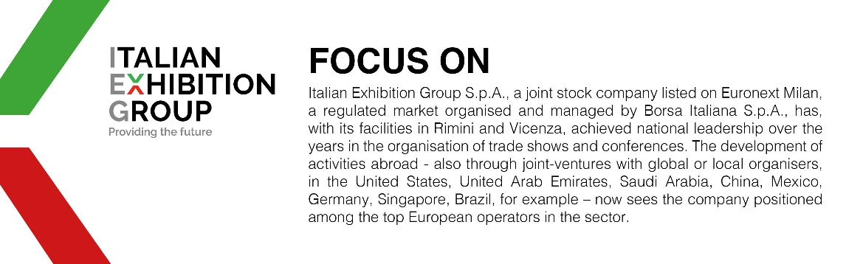

This press release contains forecast elements and estimates that reflect the management’s current opinions (“forward-looking statements”), particularly regarding future management performance, realization of investments, cash flow trends and the evolution of the financial structure. For their very nature, forward-looking statements have a component of risk and uncertainty, as they depend on the occurrence of future events. The effective results may differ (even significantly) from those announced, due to numerous factors, including, only by way of example: food service market and tourist flow trends in Italy, gold and jewellery market trends, green economy market trends; the evolution of raw material prices; general macroeconomic conditions; geopolitical factors and evolutions in the legislative framework. Moreover, the information contained in this release does not claim to be complete, and has not been verified by independent third parties. Forecasts, estimates and objectives contained herein are based on the information available to the Company as at the date of this release.

